**VIDEO GAME DIGITAL DISTRIBUTION SERVICE**



**Available Worldwide**

PARTICIPANTS – Alexander Yanev, Stephan Stratev , Kaloyan Yordanov

HEAD OF OPERATION– Hussein Abumelih

PURPOSE OF THE PROGRAM– Our purpouse to advise you to find the right game for you based on price, platform, release date, and category. By using our application you will save some of your time and discover the right game for you.

**Diagram of the program**

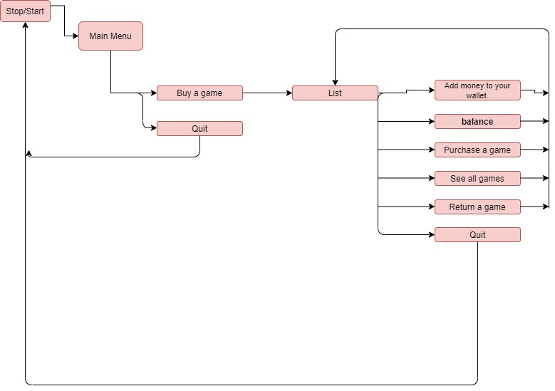

|  |  |  |  |
| --- | --- | --- | --- |
| Functions | Description | Arguments | Return value |
| Create() | Finds a game according to your requirements | GAME* games,int& size, string Platform, string Name, string ReleaseDate, string Specifications, float price | Bool function which returns true or false, depending on the success of the function |
| RemoveGame() | Removes a game from the game list and returns your money | GAME* games, int& size, int index |  |
| ShowallGames () | Shows all games in the shopping cart | GAME* games, int& size | Void function which returns a cout showing all games in the cart and if the games are purchased or they are free |
| EnterGame  Details () | Enters the details of the game you want to purchase | GAME* games, int index | Void function which returns a cout showing if the game is  Successfully purchased or if you don’t have enough money for it |
| MainMenu() | That is the main menu in which are shown all the options you have | GAME* games, int& size | Bool function which returns true or false, depending on the success of the function |

MILESTONES IN THE REALIZATION – In the prosses of making the program, we came across several different obstacles.  The main problem from the beginning was the function of the main menu. What's more, we had some problems with the output and on top of that, we had a hard time organizing the variables.

THE REALIZATION – The first ingredient toward the realization of a project is, of course, the topic so we started brainstorming for interesting ideas. After some discussion we all agreed in making a menu for a game store. The second and most important part was executing it so we all separated and started doing different sections of the project. For the hard coding, we used “Visual Studio”, for the sharing of our progress we used “GitHub”. We mostly used “Discord” for chatting and doing online meetings. For the documentation we used “Word”. And for the presentation we used “PowerPoint”. Using these platforms in-depth, showed us how many options and valuable things are specifically aimed at getting the job done easier. And we haven’t even tested it all!

CONCLUSION –In conclusion, the project really helped us grow. At first it was annoying and pressuring but as time passed, we got used to working on it. We saw how this “project” that came as a homework, became something of a daily routine.

This is the third project we have ever made and as work is considered, the 3 most important things we learned throughout the whole experience were that.

* We got better at collaborating with our teammates.
* We learned how to work with a variety of platforms.
* We made a great program and we strengthened our relation.